Entity framework core tools, sqlserver ve design yüklü olsun
Scaffold-DbContext "Server=.\;Database=KuzeyYeli;Trusted_Connection=True;TrustServerCertificate=True” Microsoft.EntityFrameworkCore.SqlServer
TrustServerCertificate=True

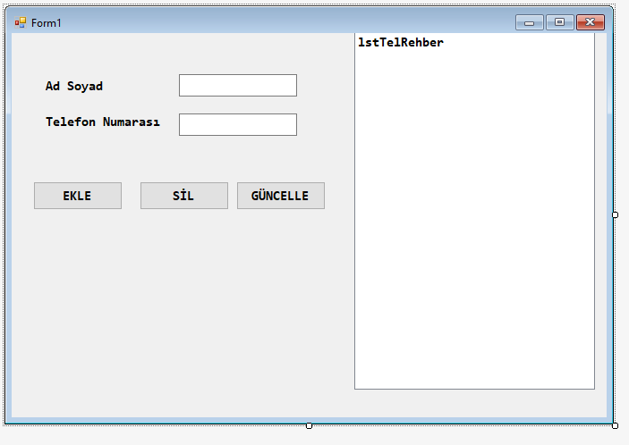
namespace telrehber
{
public class Kayit
{
public string adisoyadi;
public string telno;
public Kayit(string _adisoyadi, string _telno )
{
adisoyadi = _adisoyadi;
telno = _telno;
}
public override string ToString()
{
return adisoyadi + "--------->" + telno;
}
}
}

namespace telrehber
{
public class Telefonrehberi
{
public List<Kayit> _tel_list;
public Telefonrehberi()
{
_tel_list = new List<Kayit>();
}
public void Ekle(Kayit k)
{
_tel_list.Add(k);
}
public void Sil(int pos)
{
_tel_list.RemoveAt(pos);
}
public void Duzelt(int pos, Kayit k)
{
_tel_list[pos] = k;
}
public Kayit getKayit(int pos)
{
return _tel_list[pos];

}

}
}

namespace telrehber
{
public partial class Form1 : Form
{
Telefonrehberi _tr;
public Form1()
{
InitializeComponent();
_tr = new Telefonrehberi();
test_Verisi();
ListGuncelle();
}

private void Form1_Load(object sender, EventArgs e)
{

}
private void test_Verisi()
{
_tr.Ekle(new Kayit("Yunus ŞAHİN", "05050505"));
_tr.Ekle(new Kayit("Ayşe ÇALIŞKAN", "053205320532"));
_tr.Ekle(new Kayit("Kemal ÖZTÜRK", "05420542"));

}
private void ListGuncelle()
{
lstTelRehber.Items.Clear();
foreach(Kayit _k in _tr._tel_list)
{
lstTelRehber.Items.Add(_k.ToString());
}

}

private void btnEkle_Click(object sender, EventArgs e)
{
Kayit k = new Kayit(txtAdSoyad.Text, txtNumara.Text);
_tr.Ekle(k);
ListGuncelle();
}

private void btnSil_Click(object sender, EventArgs e)
{
int pos = lstTelRehber.SelectedIndex;
_tr.Sil(pos);
ListGuncelle();

}

private void btnGuncelle_Click(object sender, EventArgs e)
{
Kayit _k = new Kayit(txtAdSoyad.Text, txtNumara.Text);
_tr.Duzelt(lstTelRehber.SelectedIndex, _k);
ListGuncelle();

}

private void lstTelRehber_SelectedIndexChanged(object sender, EventArgs e)
{
Kayit _k = _tr.getKayit(lstTelRehber.SelectedIndex);
txtAdSoyad.Text = _k.adisoyadi;
txtNumara.Text = _k.telno;

}
}
}

